1. Introduction

1.1 Overview

Welcome to our Agricultural Yield Analysis project. In this Tableau dashboard, we delve into the world of agriculture to understand crop yields in different states and districts across India. Our analysis spans over 15 years, from 2010 to 2025, to identify trends, challenges, and opportunities in the agricultural sector.

1.2 Purpose

* Optimizing Agricultural Yields for Informed Decision-Making
* Exploring Crop Yields: Trends and Patterns Across Districts
* Agricultural Productivity Analysis: Unlocking State-Wide Insights

2. Problem Definition & Design Thinking

2.1 Empathy Map

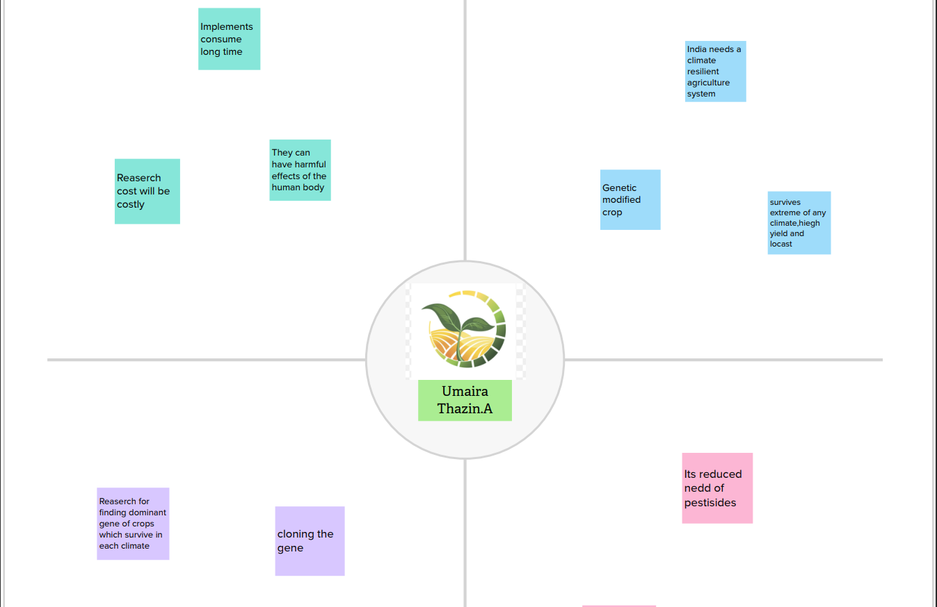

2.2 Ideation & Brainstorming Map

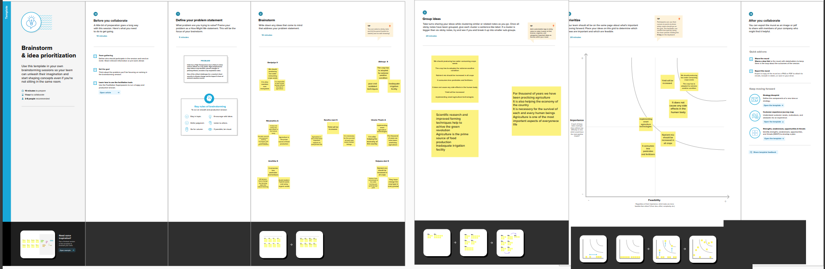

3. Result

Our analysis reveals significant disparities in crop yields among different regions. Our analysis reveals clear seasonal variations in crop yields. By tracking crop yields over time, we have identified regions where crop rotation practices can lead to more stable and productive farming. Crop rotation recommendations can enhance sustainability and minimize risks associated with monoculture. Our project promotes the power of data-driven decision-making in agriculture. Users can leverage the insights gained here to make informed choices, allocate resources more efficiently, and ultimately foster growth in the sector.

4. Advantages and Disadvantages

Advantages:

Data Visualization: Tableau excels in creating interactive and visually appealing data visualizations. It enables you to present complex agricultural data in a clear and comprehensible manner through charts, graphs, and maps.

Interactivity: Users can interact with the data using filters, sliders, and other controls, allowing them to drill down into specific details or adjust parameters to see different aspects of the data.

Accessibility: Tableau's dashboards can be accessed online or embedded in websites, making it easy to share your analysis with a wide audience, including stakeholders, policymakers, and the public.

Disadvantages:

Limited Advanced Analytics: While Tableau is great for visualizing data, it has limitations when it comes to more advanced statistical and machine learning analyses. You may need to use additional tools for in-depth statistical modeling.

Offline Access: Using Tableau in offline mode (without an internet connection) can be challenging, which may limit its usability in certain environments.

5. Conclusion:

In summary, our Agricultural Yield Analysis project serves as a comprehensive resource for gaining insights into the complex world of agriculture. Over a period of 4 years, from 2001 to 2004, we've examined crop yields at the state and district levels, enabling us to uncover significant trends and patterns.

Throughout this analysis, we've unearthed key findings, such as the consistent high-yield performance of State, the influence of Year on a remarkable increase in crop yields, and the dominance of Crop as the most cultivated crop across regions.

Our mission is to empower informed decision-making within the agriculture sector. We believe that these insights can be instrumental in shaping strategies, policies, and practices that promote sustainable agriculture, bolster food security, and uplift the livelihoods of farming communities.